**Experiment No. 3**

Aim: To build a simple network topology and configure it for static routing protocol using packet tracer.

Requirements: Windows OS in P.C and Stable version of CISCO packet tracer.

Theory:

The arrangement of wires, work stations (P.C.) and other peripherals in a network is known as network topology.

Some of the topologies widely known and in used are Mesh Topology, Star Topology, Bus Topology, Ring Topology and Hybrid Topology (combination of two or more topology).

We’re using simple network topology analogous to Star topology for static routing protocol using CISCO packet tracer.

Network Configuration:

1) There are 2 different Gateways (having different address) connected through switch and hub using copper cross-over wire.

2) Switch in 1st gateway is connected to two P.C. in Star topology using copper straight-through wire each having same Gateway address but different I.P address.

3) Hub in 2nd gateway is connected to two P.C. in Star topology using copper straight-through wire each having same Gateway address but different I.P address.

Demonstration of sending packet from PC0 (in 1st Gateway) to PC3 (in 2nd gateway):

1) Packet send from PC0 to Switch:

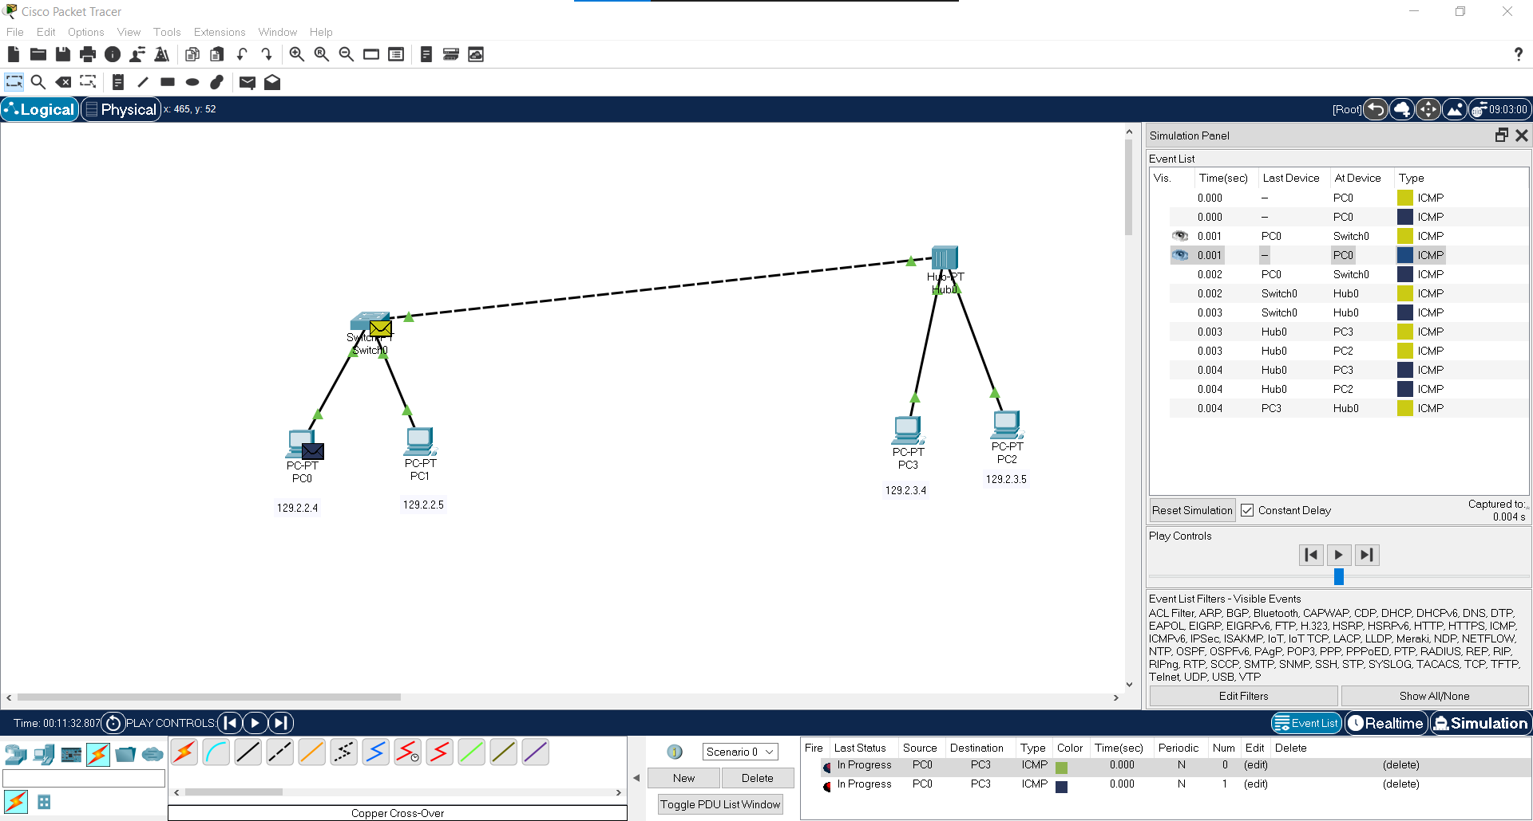

2) Packet route to HUB from switch which in turn route to all PC in HUB network and PC3 accepted the package and other PC rejected it:

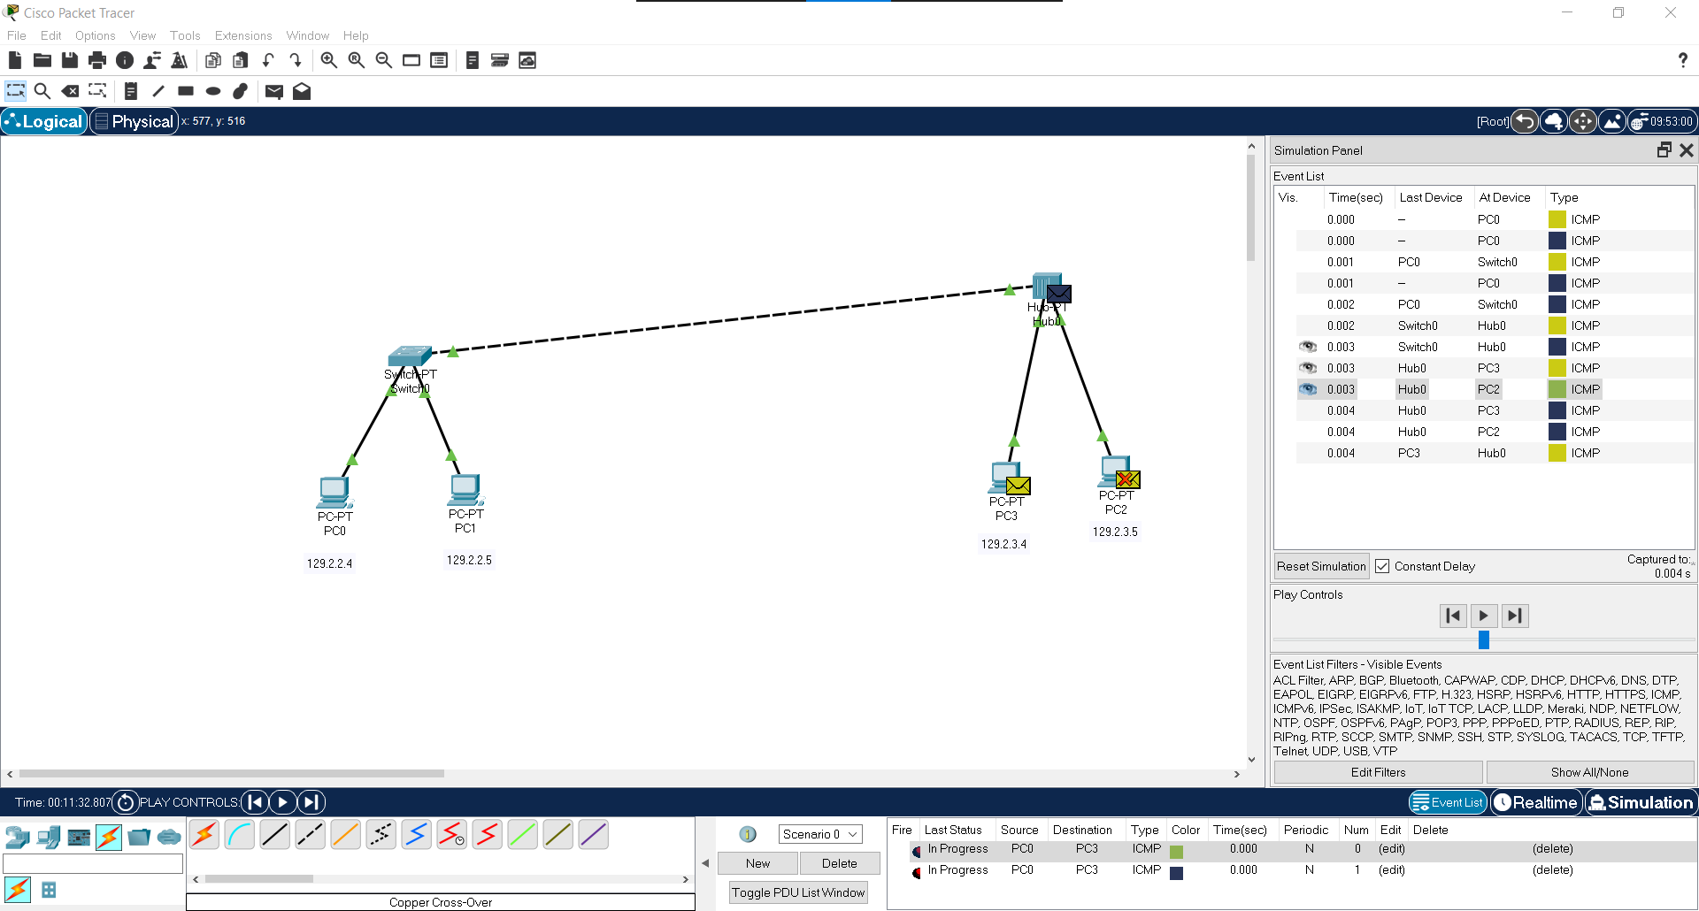

3) PC0 received acknowledgment packet has been delivered successfully:

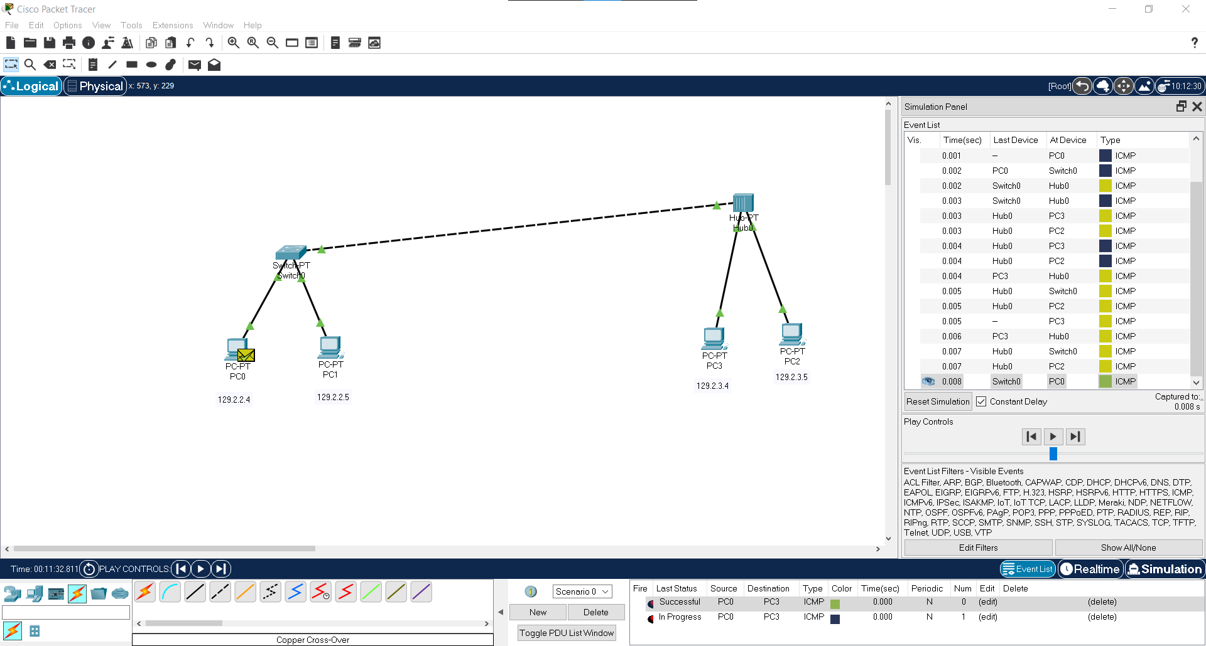

Conclusion: We have successfully understand the concept of network topology and built a simple network topology and configure it for static routing protocol using CISCO packet tracer.